Procedure for when a patient phones requesting a repeat on their medication
NB: For this process to work it takes some work from the GP’s; at the beginning the GP will need to set up a ‘Face to Face’ task for each patient on regular medications. They do this as the requests come through. This took us about 6 months overall, but has now been a successful process for over 2 years with only minor tweaking. Once the ‘Face to Face’ tasks are set for each patient the process really becomes a lot easier.
The process is based on the task becoming aged, in My Practice when this happens the task changes colour (sorry I am unsure if this happens in Med Tech). Green/Orange: a prescription request can go ahead, Brown/Red: the patient is due for a medicine review so needs an appointment.
When the patient phones in, they have the option to go straight through to the prescription line which is manned by an administrator. The administrator then follows the following process.
The colour of the task shows the administrator straight away whether the patient requires an appointment or if a prescription request can go through. This saves a lot of time for admin having to phone back when the GP says that they are due a medicine review.
- Go to the Repeat Prescription Tab on the top tool bar

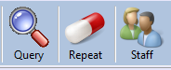
- Click on it
- Type in the patient’s name or DOB in the search box

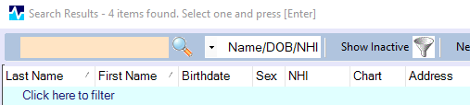
- Click on the patients name and click “OK” (You can also double click on the patients name)
- The Repeat Prescription screen will appear
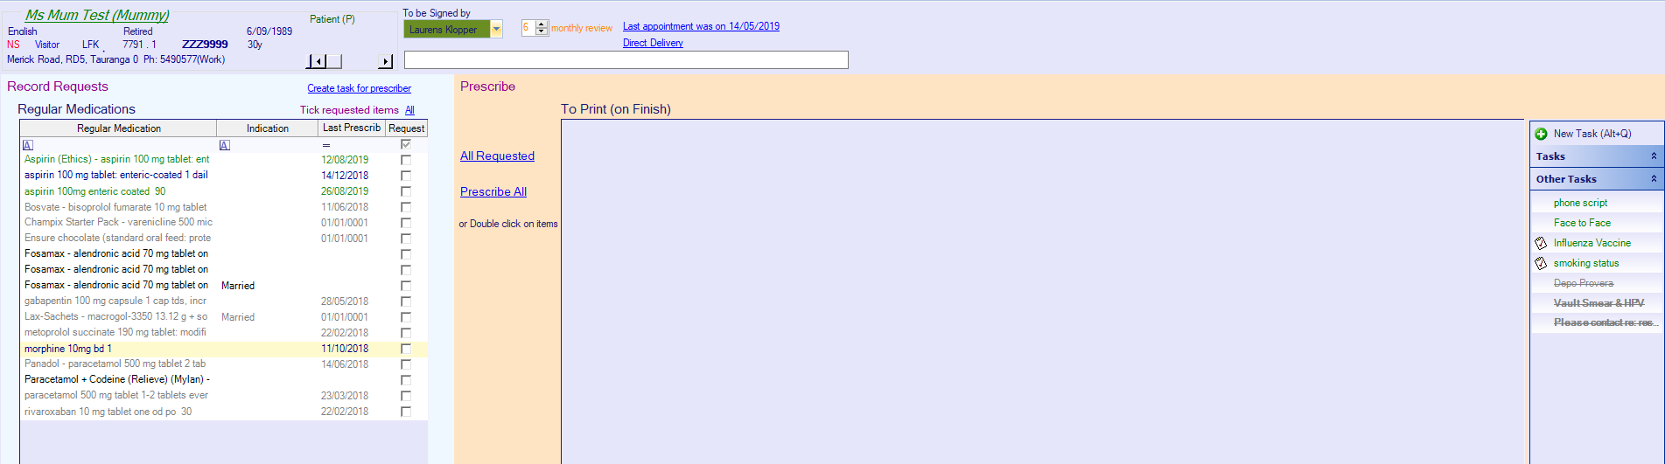
- Look to the right hand side under “Other Tasks” there should be a task saying “Face to Face”
- If “Face to Face” is in GREEN or ORANGE you can go ahead and process the request
- If “Face to Face” is BROWN or RED it means that the patient is due a medical review with their GP. Advise the patient and ask how much medication they have left. See if you can get an appointment with their GP before they run out. IF Not – Follow the TIDE-OVER SCRIPT process and put through the medication request as below.
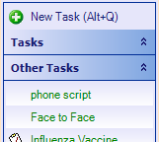

MEDICATIONS
- Ask the patient what medication they are requesting and click on the boxes beside the medication that are listed under “Regular Medications”. Do NOT click on the words.
  - NB: The patient MUST give you the medication’s name; they cannot simply say “my regular meds”. If they do not have the name/s of the medication they require, ask them to phone back with it,
  - Look at the last prescribed date to see if they have received a script for that item in the last 3 months. If they have, open clinical notes and check on the left-hand side to see if there are any repeats available on that medication and at what pharmacy. NO Script request is required if they have repeats at the pharmacy.
  - If there is medication on the regular list that they have had recently and have not asked for, ask them if they require it this time. If they do not require it this time, make sure you note the reason in the request for the doctor to see.

- If the patient requests a medication that does not appear on the “Regular Medications” list. Type the name of the medication in the box shown here.

- Check the prescriber is here and not on annual leave. If on annual leave, direct the task to the GP who is looking after the absent GP’s paperwork.

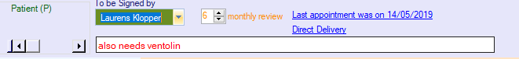

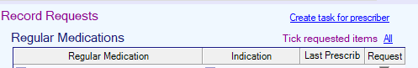
- Click on “Create task for prescriber”

- A task will appear titled “Repeat Prescription” under “New Task”. This will send a task to the selected doctor.
- Open the task and write the pharmacy that they require the medication to go to and enter that into the task so that it is initialled, and time stamped.
- If it is a different pharmacy than that recorded under the Last Appointment date, select the pharmacy recorded and search for the correct pharmacy.
If it is a temporary pharmacy use “select temporary pharmacy”. If it is one they want to use permanently use “select usual pharmacy”.
- If there are any further notes for the Doctor – such as, does not need “XYZ” as still has a full supply, open the task and record these notes at the bottom of the task.

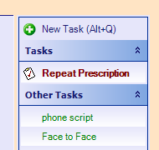

Urgent Script – If a script is Urgent for today, ensure you let the person know that this has an extra cost. In the task Description put URGENT at the start. Make sure the doctor is working today, if not it will go to the ACUTE doctor.
Put a script task on the Results/Prescription section of the doctor’s template for today. Add appointment note that it is urgent for today.

