Pictured: a taonga carved and gifted to us by one of our patients, which now hangs in our 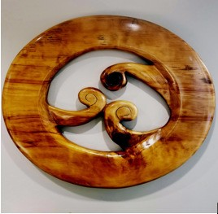reception area

Kia ora

You may be wondering why you have been sent this survey, and do I **have** to do it?

The short answer is no, you don’t – this survey is by no means compulsory.

The long answer is that we would **love** to have as much input from our Māori patients as possible so we can find gaps in our service delivery and work better with and for you.

We are aware that Māori communities experience a range of barriers when accessing health and wellbeing services. These are something that we are actively trying to remove. We believe that the best people to ask about their experiences with us and changes they would like to see are those who are enrolled with us.

We need your honest views about your experiences with us, starting from the moment you pick up the phone to call us or work through our door. We plan to build your feedback into our ongoing quality improvement plan and review our progress throughout the year.

We do very much appreciate your time and your thoughts, experiences, suggestions and feedback.

We would be grateful to receive your completed survey by Friday 27th October. You can return it via email to [jack@ttmc.co.nz](mailto:jack@ttmc.co.nz), by dropping it in at reception, or, if you prefer to remain anonymous, by posting it to us at PO Box 10 184, Wellington.

Ngā mihi nui

The Terrace Medical Centre