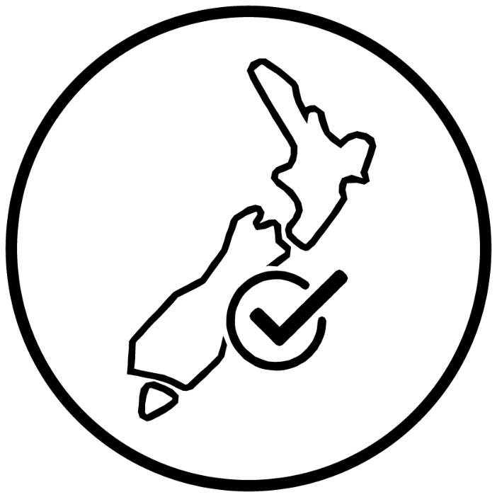

Primary Care Onboarding Guide

Steps for setting up a COVID-19 vaccination site
Version 2.1
Last updated 4th August 2021

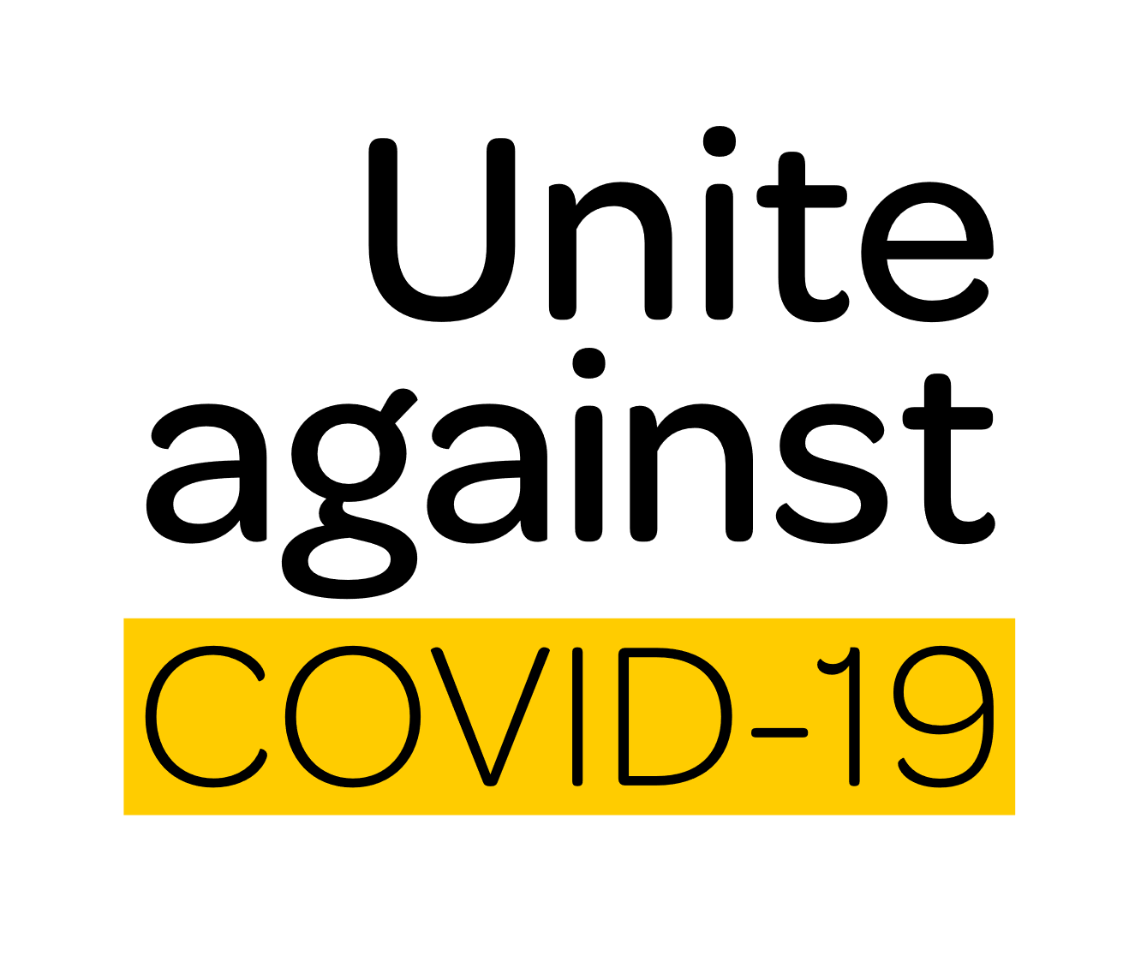

Document control
Revision history | Date | Details
1.0 | 19 July 2021
2.1 | 3 August 2021 | Updates to logistics guidance
Note: This document is regularly updated. For the most up-to-date version, please visit the Ministry of Health (MoH) website

Contents
Primary Care Onboarding Guide 1
Section 1: Introduction 4
Timeframes and DHB engagement 4
Clinical leadership and vaccination sites 4
Equity 5
Section 2: The onboarding journey 6
Step one – site setup 7
Step two – clinical considerations 8
Step three – workforce training and onboarding 9
Step four – invitations and bookings 10
Step five – inventory, forecasting, vaccine ordering 11
Step six – vaccination 12
Step seven – payments and invoicing 13
Step eight – payments and invoicing – PPD 14
Step nine – reporting and monitoring 15
Section 3: Questions and feedback 16
Updates 16
Feedback and questions 16
Section 4: Glossary 17
Glossary of terms 17
Abbreviations 17
References 18

Section 1:
Introduction
Primary Care providers are a critical component of the New Zealand COVID-19 vaccination rollout.
This Onboarding Guide is for primary care providers who have been commissioned by their local DHB or primary health organisation (PHO). The guidance provided assumes an agreement between the primary care provider and DHB/PHO is signed, and the proposed vaccination site is appropriately accredited.
This Onboarding Guide references and should be read in conjunction with:
  - COVID-19 Vaccine Operating Guidelines
  - BioNTech/Pfizer COVID-19 Vaccine and Immunisation Programme Planning Blueprint: Planning blueprint: Workplace sites
  - The Immunisation Handbook 2020
  - New Zealand COVID-19 Immunisation Programme Service Standards
  - Professional body clinical and quality standards (including RNZCGP, RNZCUC,
PSNZ, CNNZ)

Timeframes and DHB engagement
The starting point for establishing vaccination sites is a formal commissioning agreement with your local DHB. The onboarding process follows, providing guidance on clinical, workforce, technology, and logistics considerations.
Timeframes for DHB or PHO preparations can vary. Formal DHB sign-off is required prior to engaging with the Ministry of Health (the Ministry). Please allow ten (10) working days to process the relevant technology, payment, and logistics after submitting your initial site information.

Clinical leadership and vaccination sites
Becoming a COVID-19 vaccination site can be complex, involving engagement with both your local DHB and/or PHO and the Ministry. To ensure patient safety, vaccination sites will need an appointed clinical site lead to navigate the onboarding process. Clinical site leads are accountable for meeting clinical safety and quality standards at their site, as well as supporting planning, clinical governance, quality, and safety management processes.

Equity
Vaccination sites should be accessible to all members of your community and provide for equitable outcomes for Māori, Pacific, other ethnic communities, and people with disability. Take reasonable steps to improve access and reduce potential inequalities, such as:
- incorporating Te Tiriti O Waitangi considerations into your site setup and workforce (such as karakia, engaging with local Iwi, Hapū and whānau)
- site and location considerations for Māori and Pacific (such as accessibility, location, language)
- ensuring access for people with disability. Visit the Ministry of Health for more information on venue accessibility
- ensuring staff are educated in disability equity issues and know how to employ a rights-based approach. A 30-minute eLearning is available through the Ministry of Health LearnOnline website

Section 2:
The onboarding journey

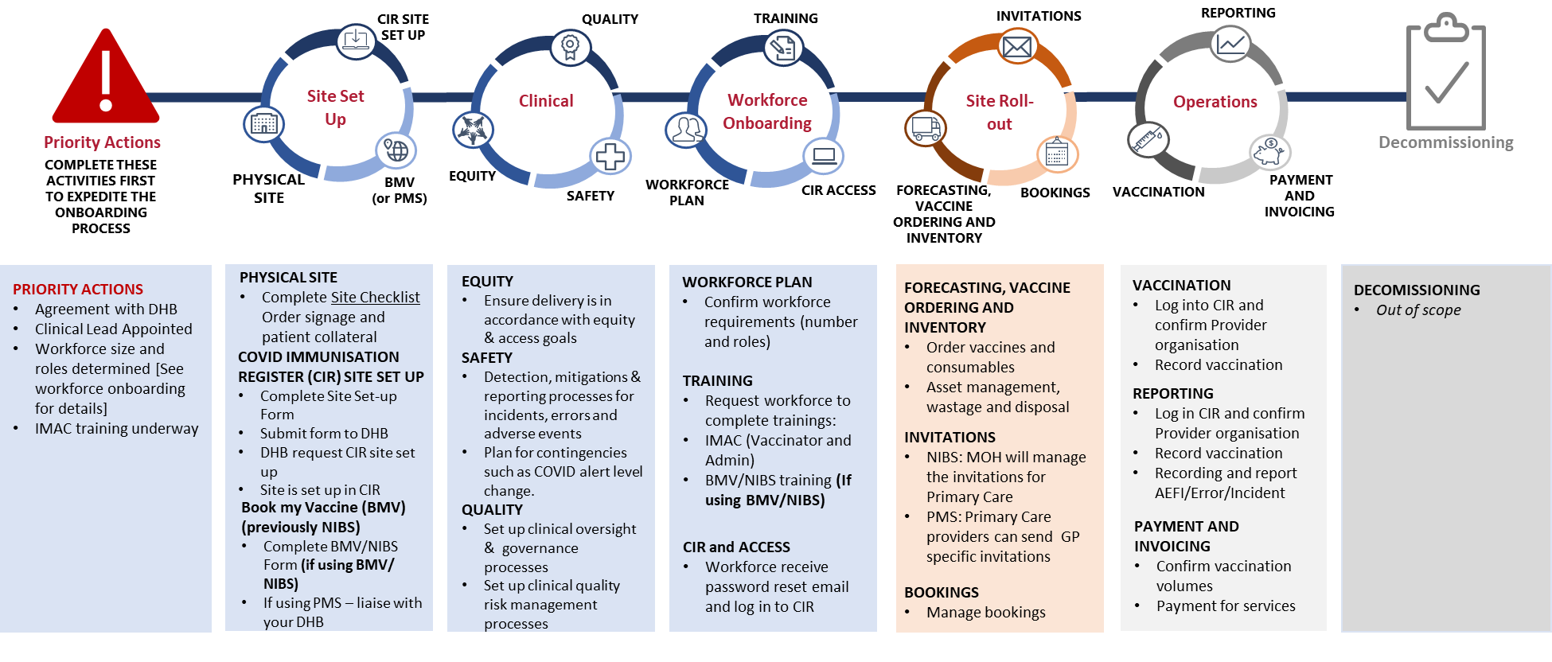Onboarding steps
Step one
Site setup
Step two
Clinical
considerations
Step three
Workforce training
and onboarding
Step four
Invitations and
bookings
Step five
Inventory, forecasting,
vaccine ordering
Step six
Vaccination
Step seven
Payments and
invoicing
Step eight
Payments and
invoicing – PPD
Step nine
Reporting and
monitoring

Step one – site setup
Steps | Supporting documents | Where to get help | Checklist
1 Complete the COVID-19 Immunisation Register (CIR) site setup form  - Send to COVID-19.logistics@health.govt.nz  [with Ministry of Health regional account manager cc’d] | Site setup form  Site setup form (Operating Guidelines - Appendix B) –  Or contact your [Insert DHB operations lead contact] | Site setup  [Insert DHB/PHO operations lead contact]  [Insert Ministry of Health regional account manager contact] | - Site setup form completed  - Site setup form submitted for sign-off by DHB CE
2 Complete national immunisation booking system (NIBS) form (if using)  Send to [DHB/PHO operations lead] | NIBS form (if using) – contact your [Insert DHB operations lead contact] to request the form  COVID-19 Vaccine Immunisation Programme Service Standards | Technology  Ministry of Health CVIP helpdesk  0800 223 987 (daily 8am-6pm)  help@c-19imms.min.health.nz  For other technology queries such as browsers, internet, hardware, please contact your IT provider | - NIBS setup form completed  (if using)
3 Order site collateral  Submit order for signage and patient collateral to [DHB communications lead] | Operating Guidelines – Ordering Site Collateral | [Insert DHB communications lead contact] | - Site collateral ordered
4 Complete site checklist | Site checklist  - Site checklist (Operating Guidelines – Appendix A) | [Insert DHB/PHO operations lead contact]  Primary Care planner sessions (3-4pm Monday-Friday, 5.30-6.30pm Tuesdays and Thursdays) | - Site checklist completed
Step two
Clinical
considerations
Step two
Clinical
considerations
Step two
Clinical
considerations
Step two
Clinical
considerations
Step two
Clinical
considerations

Step two – clinical considerations
Steps | Supporting documents | Where to get help | Checklist
1 Confirm clinical oversight, governance, and quality processes at site | HQSC Clinical Governance Advice  Operating Guidelines - Clinical Leadership  Vaccine Planning Blueprint  COVID-19 Vaccine Immunisation Programme Service Standards | [Insert DHB/PHO clinical lead]  Local PHO  For detailed guidance, refer to your professional body for example RNZCGP foundation standards | - Clinical governance processes and frameworks in place for site, communicated to teams
2 Confirm clinical safety and incident management processes | HQSC SAC Rating and Triage Tool  Vaccine Planning Blueprint  Incident Process Steps (Operating Guidelines) |  | - Detection, mitigations, and reporting processes in place for incidents, errors, and adverse events
3 Determine site equity considerations and plan | Disability planning and accessibility  at Ministry of Health website  Disability eLearning LearnOnline | [Insert DHB/PHO operations lead contact] | - Equity challenges identified, mitigations in place

Step three
Workforce training
and onboarding

Step three – workforce training and onboarding
Steps | Supporting documents | Where to get help | Checklist
1 Determine workforce requirements (numbers and types of roles) | Operating Guidelines – Preparing the Vaccination Site Workforce | Primary Care planner sessions (3-4pm Monday-Friday, 5.30-6.30pm Tuesdays and Thursdays)  Local PHO | - Assigned workforce to clinical and  non-clinical functions required at vaccination site
2 Send IMAC link to complete relevant training:  Once your DHB workforce lead receives notification that your staff have completed the required training, access to the CIR will be arranged. | User onboarding process compulsory training materials:  Technology, user roles and training matrix  A guide to the IMAC COVID-19 education course processes  CIR user request form (provided by DHB workforce lead)  IMAC preparation and administration document | IMAC Link to eLearning courses  [Insert DHB/PHO workforce lead contact] | - Workforce has received links/details to complete relevant training  - IMAC training completed for vaccinators, site administrators  - DHB acknowledged training complete  - Registration for CIR and NIBS submitted by DHB workforce lead
3 Ensure the workforce have been provided access to relevant solutions and that they have logged on to reset their password within 24 hours | User onboarding CIR | [Insert DHB/PHO workforce lead contact]  Ministry of Health CVIP helpdesk  0800 223 987 (daily 8am-6pm)  help@c-19imms.min.health.nz | - Workforce have activated their access to required systems  such as NIBS, CIR, inventory portal, payments

Step four
Invitations and
bookings

Step four – invitations and bookings
Steps | Supporting documents | Where to get help | Checklist
1 Complete BMV/NIBS training | Technology, user roles and training matrix  COVID-19 Vaccine Immunisation Programme Service Standards | Primary Care planner sessions (3-4pm daily, 5.30-6.30pm Tuesdays and Thursdays) | - BMV/NIBS user training complete
2 Confirm BMV/NIBS access for site admin/concierge (one to two people per site) | How to manage bookings and hours – quick step guide  Managing site capacity using overrides  User onboarding for BMV/NIBS | Ministry of Health CVIP helpdesk  0800 223 987 (daily 8am-6pm)  help@c-19imms.min.health.nz  Join a Teams drop in session at https://tinyurl.com/yty4q6td  (9.30am-10.30am Mon-Fri) | - BMV/NIBS access confirmed for site users (one to two)
3 Configure site availability and capacity |  | [Insert DHB/PHO operations lead] | - Site availability confirmed by site admin/concierge
4 Confirm site bookings in BMV/NIBS |  |  | - Bookings reviewed by site admin/concierge

Step five
Inventory, forecasting,
vaccine ordering

Step five – inventory, forecasting, vaccine ordering
Steps | Supporting documents | Where to get help | Checklist
1 Confirm vaccine capacity and completion of the site setup form | Forms  Site setup form, sent to COVID-19.logistics@health.govt.nz  [with Ministry of Health regional account manager cc’d]  Guidance  - Logistics cheat sheet – Operating Guidelines | [Insert DHB/PHO inventory lead contact]  [Insert Ministry of Health regional account manager contact]  Ministry of Health CVIP helpdesk  – Passwords/after-hours support  0800 223 987 (8am-6pm)  help@c-19imms.min.health.nz | - Vaccination capacity confirmed  - Site setup form completed
2 Complete forecasting and ordering vaccines and consumables  Forecasting  Vaccine ordering and logistics  Consumables  PPE  Communications materials | Guidance  - Operating Guidelines - Logistics and Inventory Management  - Inventory Training Videos -Placing an order  - Inventory Orders Portal Quick Step Guide  - DHB ordering communications materials and guidance  Forms  - DHB ordering and logistics guidance | [Insert DHB communications lead contact]  [Insert DHB inventory lead contact]  Primary Care planner sessions (3-4pm Monday-Friday, 5.30-6.30pm Tuesdays and Thursdays)  Ministry of Health logistics team  0800 335 778 (daily 9am-5pm)  COVID-19.logistics@health.govt.nz (8am-8pm) | - Vaccine, consumables and supporting materials (PPE, communications material) ordered and received in advance of bookings
3 Review inventory management and disposal  Stocktake, review, disposal, and wastage | Operating Guidelines - Logistics and inventory management  Operating Guidelines – Interwaste disposal | [Insert DHB inventory lead contact]  Interwaste disposal  0800 102 131 (business hours) | - Inventory consumption, wastage and stock on hand captured, per DHB guidance  - Confirm Interwaste disposal contract is in place
Step six
Vaccination

Step six – vaccination
Step seven
Payments and
invoicing
Steps | Supporting documents | Where to get help | Checklist
1 Complete reception/pre-vaccination event | Operating Guidelines – Vaccination and Observation  CIR Reception Quick Step Guide | Clinical vaccine queries  0800 IMMUNE (466 863), option 1 (health professionals) and then option 2 (COVID-19 vaccinator support)  CIR technical support  CIR technical support for booking and access: help@c-19imms.min.health.nz  or 0800 223 987 (daily 8am-6pm)  Join a Teams drop in session at https://tinyurl.com/yty4q6td  Primary Care planner sessions (3-4pm Monday-Friday, 5.30-6.30pm Tuesdays and Thursdays)  - Working with CIR Suite drop-in sessions (12-1pm Monday-Friday) | - Patient identity confirmed  - Patient does not have COVID-19 symptoms  - Consent form (if used) completed  - Pre-vaccination clinical assessment completed
2 Administer vaccination | Operating Guidelines - Vaccination and Observation  COVID-19 vaccination information and consent pack  Immunisation Handbook  IMAC training  CIR Vaccination Quick Step Guide |  | - Consent recorded in CIR  - Vaccine administered and recorded in CIR  - Written consent form  (if used) collected and uploaded into CIR
3 Complete observation  Monitor patient for 20 minutes for any adverse events, and record if required | COVID-19 Vaccine Operating Guidelines  – Proof of Vaccination  CIR Observation Quick Step Guide  Recording overseas vaccinations |  | - Patient released from observation as appropriate
4 Monitor patient post event  Support patients where appropriate to record post observation adverse events  Report any serious incidents as they arise | COVID-19 Vaccine Operating Guidelines  – Vaccination and Observation  CARM form  CIR Adverse Event Quick Step Guide |  | - Adverse events recorded where appropriate

Step seven – payments and invoicing
Steps | Supporting documents | Where to get help | Checklist
1 Complete agreement (step completed before site setup) | Payment and invoicing guidelines  Payment and invoicing guidance | [Insert Ministry of Health regional account manager contact]  [Insert DHB/PHO operations lead contact] | - Active contract in place with DHB  - Confirm agreement details (agreement number and payment mechanism)
2 Record vaccination – select correct provider organisation | Recording a vaccination (CIR)  CIR Vaccination Quick Step guide | CIR helpdesk  help@c-19imms.min.health.nz or  0800 223 987 (daily 8am-6pm) | - Correct provider selected, vaccine administered and recorded in CIR
3 Submit invoice |  | Payment queries  Invoice provider payments  providerinvoices@health.govt.nz  Contract queries  Contract setup helpdesk  dunedinaasupport@health.govt.nz | - Confirm vaccine volumes  - Send invoices

Step eight
Payments and
invoicing – PPD

Step eight – payments and invoicing – Price Per Dose (PPD)
Steps | Supporting documents | Where to get help | Checklist
1 Complete agreement (step completed before site setup) | Forms  Site setup form, sent to COVID-19.logistics@health.govt.nz  [ with Ministry of Health regional account manager cc’d] | [Insert Ministry of Health regional account manager contact]  [Insert DHB/PHO operations lead contact] | - Agreement signed and contract number issued  - Contract number provided in site setup form  - Provider facility and site communicated to workforce
2 Record vaccinations – select correct provider organisation | Recording a vaccination (CIR)  CIR Vaccination Quick Step guide | CIR helpdesk  help@c-19imms.min.health.nz  or 0800 223 987 (daily 8am-6pm) | - Correct provider selected, vaccine administered and recorded in CIR
3 Run payments management report, update payment details (if required) and invoice reconciliation | CIR Training and guidelines  Payment management report quick step guide | Report access  help@c-19imms.min.health.nz  or 0800 223 987 (daily 8am-6pm)  Contract queries  Contract setup helpdesk  dunedinaasupport@health.govt.nz  Payment helpdesk  Contract setup helpdesk  CovidPaymentSupport@health.govt.nz | - Run report and check for any payment issues (such as negative or failed status)  - Vaccination record updated (if required)  - Confirm payment received  - Receipt (BCTI) file received (weekly), please allow up to two (2) weeks for NZ Post delivery)

Step nine
Reporting and
monitoring

Step nine – reporting and monitoring
Steps | Supporting documents | Where to get help | Checklist
1 Access reporting in CIR | CIR training and guidelines  Site Summary Quick Step Guide | CIR helpdesk  help@c-19imms.min.health.nz  or 0800 223 987 (daily 8am-6pm) | - Training materials have been read and understood  - CIR account has been activated and successfully logged into  - Access to site overview tab  - View and monitor graphs and reports
2 Access reporting in NIBS | NIBS training and guidelines  NIBS site admin – reports guide  NIBS – Train the Trainer Manual [Contact your local DHB for guidance]  NIBS – Training Manual [Contact your local DHB for guidance] | NIBS technical support for booking, access, and queries  help@c-19imms.min.health.nz or  0800 223 987 (daily 8am-6pm)  Join a Teams drop in session at https://tinyurl.com/yty4q6td  [times TBC] | - Training materials have been read and understood  - AVMS account has been activated and successfully logged into  - Access to reports tab  - Review, monitor and export reports

Section 3:
Questions and feedback

Updates
This document will be updated regularly to reflect changes in policy and guidance, new technology functionality, and feedback from primary care providers. Future iterations will be available on the Ministry of Health website under COVID-19 - information for health professionals.

Feedback and questions
We welcome feedback and questions on the use of this onboarding guide. Please submit your questions and feedback to Onboarding@Health.govt.nz, where we will confirm receipt within 24 hours. If you have questions specific to a component of onboarding, please refer to the contact list below.
Topic | Contact Details
Site setup  (NIBS)  Payments and invoicing | Ministry of Health CVIP helpdesk  0800 223 987 (8am-6pm)  help@c-19imms.min.health.nz
Clinical vaccination queries | Clinical vaccine queries  0800 IMMUNE (466 863), option 1 (health professionals)  and then option 2 (COVID-19 vaccinator support)
Logistics (including ordering, inventory, delivery queries) | Ministry of Health logistics team  0800 335 778 (daily 9am-5pm)  COVID-19.logistics@health.govt.nz (8am-8pm)

Section 4:
Glossary

Glossary of terms

Abbreviations
Abbreviation | Full name
BCTI | Buyer-created tax invoice
CIR | COVID-19 immunisation register
DHB | District health board
IMAC | Immunisation advisory centre
BMV | Book my Vaccine (previously known as NIBS)
NIBS | National immunisation booking system
PHO | Primary health organisation
PPD | Price per dose
The Ministry | Ministry of Health
PPD | Price per dose
The Ministry | Ministry of Health

References
Ministry of Health. 2021. Operating Guidelines for DHBs & Providers. Wellington:
Ministry of Health
Ministry of Health. 2021. BioNTech/Pfizer COVID-19 Vaccine and Immunisation Programme. Wellington: Ministry of Health
Ministry of Health. 2020. Immunisation Handbook. Wellington: Ministry of Health.
Ministry of Health. 2021. New Zealand COVID-19 Immunisation Programme Service Standards. Wellington: Ministry of Health

