1. In the Immunisations module, go to the tab Schedule Selection and **add patient to the Flu and Shingrex schedules.**

1. Move to the first tab, Immunisations Schedule, and select **Add a New Immunisation Group** from the actions drop down box (or the second needles icon).

1. This opens the flu imms details. At the bottom of the box, click on **Add/Remove button, and select ‘0 Shingrex Co-Admin Vac’**.

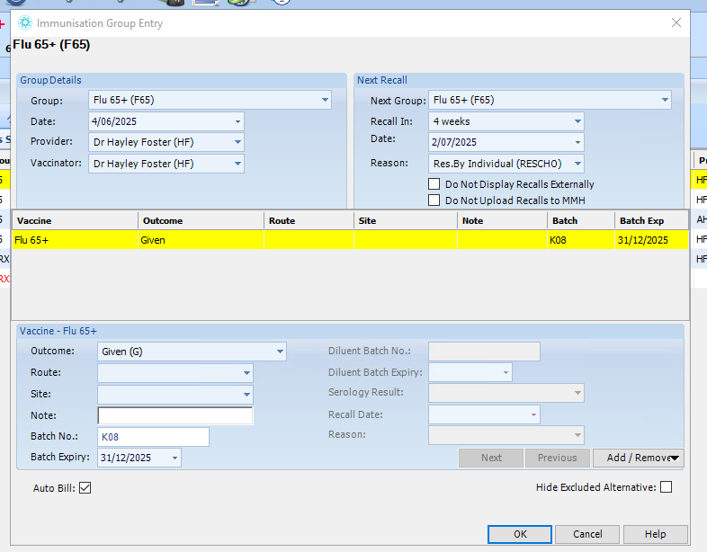

1. This will add the Shingrex vaccine. **You need to click on the Shingrex Co-Admin Vac – this will allow you to add the imms administration details in the area below.** Once you have done this, click **okay** and the claim will have been generated (using auto-bill).

1. You can check the claim has been generated by opening the invoice – you should see the below claims.

